Monday 9th March 2015

Dear Parents,

Please find attached a letter from the Local Authority regarding the Home to School Transport Policy Consultation Stage 2.
The Council now wishes to consult further on fare levels from September 2016 for all
non-statutory travellers by introducing a fare table based on mileage.
The consultation period will operate for 10 weeks and will end on 15th May 2015. The Executive Member for Schools and Education will consider the consultation responses before making a final decision on all matters consulted on.

The consultation document is available through the following link http://bit.ly/bwdh2stc
You can respond on line by emailing hometoschool.transport@blackburn.gov.uk or alternatively by post to the Director of Children’s Services, 10 Duke Street, Blackburn. BB2 1DH, if you wish to take part.

A copy of the documents are available on the school website:
www.stbedesblackburn.com

Yours sincerely
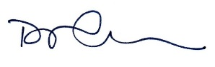
Mr D Callaghan
Headteacher

