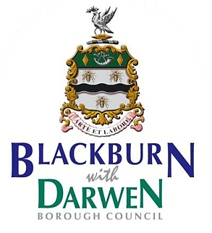

 | Date:  My Ref:  Please Ask For:  Telephone Number: | 9th March 2015  HTS/Con2  Mebz Bobat  01254 666510

Dear Parent/Guardian

Home to School Transport – Stage 2 Consultation

As you will be aware the Council is continuing to face exceptionally tough times with ever reducing resources which is forcing detailed consideration of all its current and future services. The Council has experienced unprecedented reductions in funding from Central Government each year since 2010 which has resulted in very real reductions to local public services. The Council is now facing a situation where a further £31 million of savings have to be made over the next three years and therefore needs to look at spending on services that have no legal requirement.

The Council fully appreciates the importance of Home to School Transport within the Borough and its key role in underpinning day to day journeys for Blackburn with Darwen school children. A consultation on changes to the transport policy was undertaken between November 2014 to January 2015. The responses to questions in the first consultation fall into 3 categories:
- broad agreement with the proposals – majority of respondents agreed with the proposals
- no clear majority view but proposals are non-controversial or have minimal impact
- disagreement or controversial – majority of respondents disagreed or the impact on some parents is significant.
The main issue was over the potential increases in the daily fare for pupils who did not receive a statutory pass. We are now consulting further on fare levels from September 2016 for all non statutory travellers by introducing a fare table based on mileage. The fare of £2.50 return for journeys under 3 miles will be maintained.
Where schools contribute to the school bus service subsidy, the Council will seek to maintain the lower rate fare for the whole journey. School bus services are contracted for the following:
- In Blackburn: St Bede’s RC High, St Wilfrid’s CE Academy, Our Lady & St John’s Catholic College,
- In Darwen: Darwen Aldridge Community Academy,
- In Bolton: Canon Slade CE High and Turton High School.

To date, the following schools have agreed to contribute to the subsidy arrangements or provide bus services directly: St Bede’s RC High; St Wilfrid’s CE Academy and Our Lady & St John’s RC High.

The consultation period will operate for 10 weeks and will end on 15th May 2015. Our Executive Member for Schools and Education will consider the consultation responses before making a final decision on all matters consulted on.

The consultation document is available through the following link http://bit.ly/bwdh2stc
You can respond on line by emailing hometoschool.transport@blackburn.gov.uk or alternatively by post to the Director of Children’s Services, 10 Duke Street, Blackburn. BB2 1DH, if you wish to take part.

Yours sincerely

Linda Clegg
Director of Children’s Services

